**Bewegungen Holly jolly Christmas**

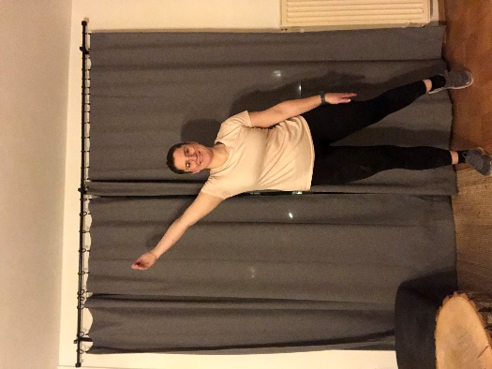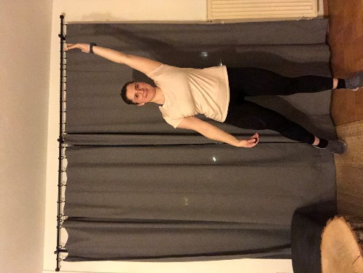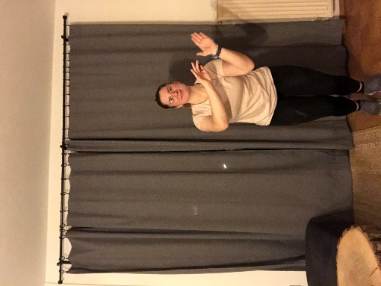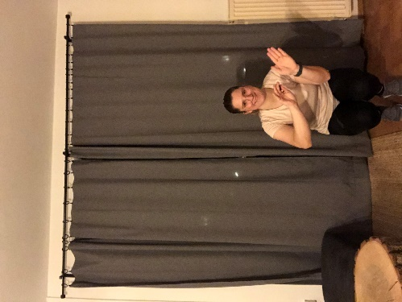

Have a holly jolly Christmas

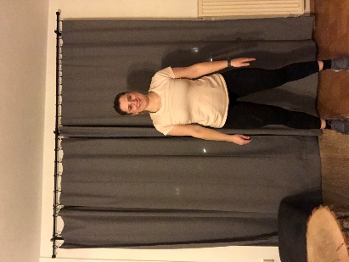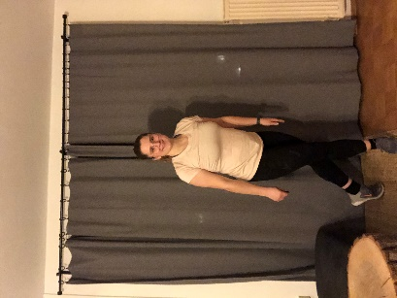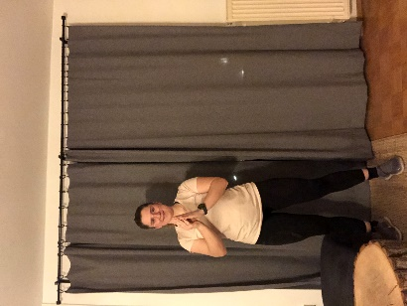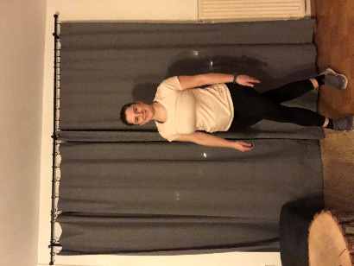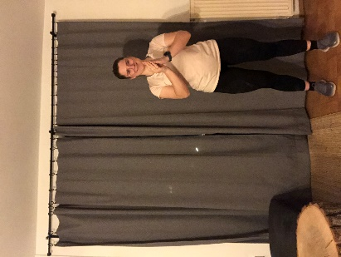

It's the best time of the year

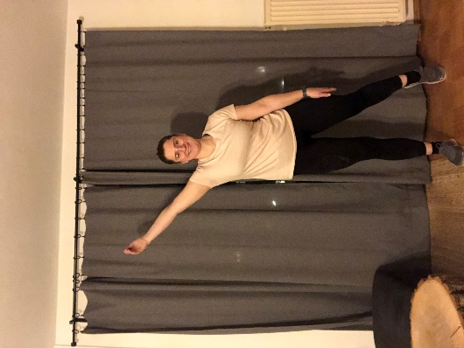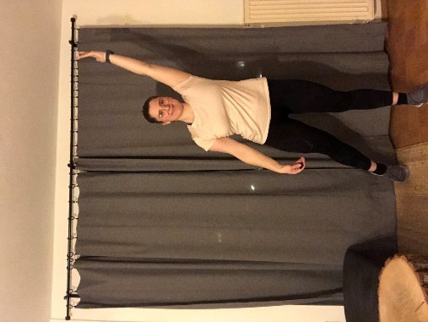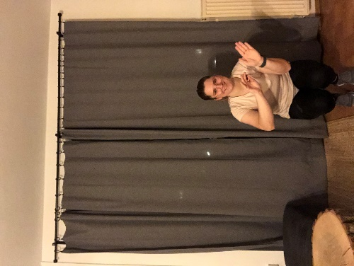

Now I don't know if there'll be snow  
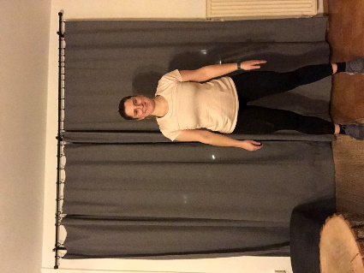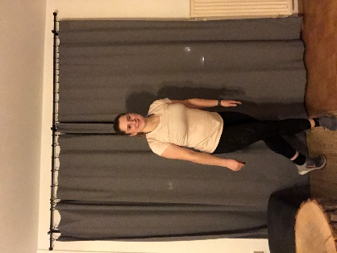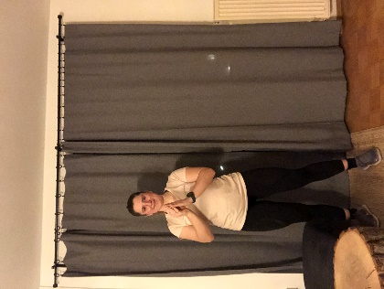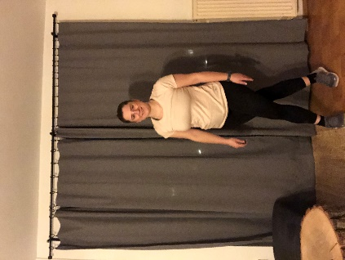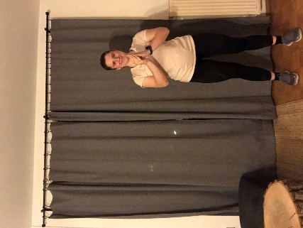

But have a cup of cheer

**Wiederholung der Tanzschritte**

Have a holly jolly Christmas  
And when you walk down the street  
Say hello to friends you know  
And everyone you meet

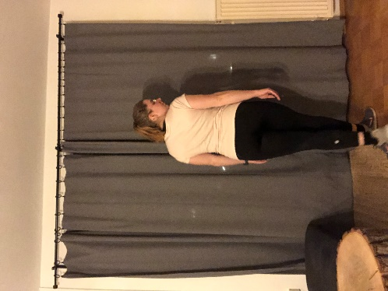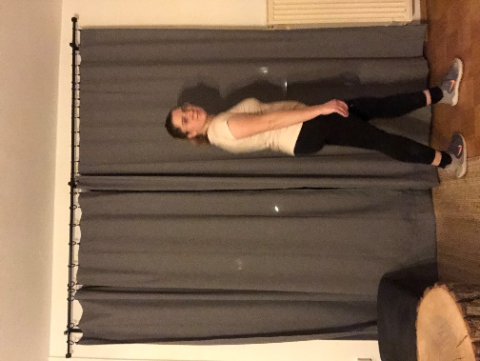(vier Schritte im Kreis gehen)

Ho ho the mistletoe

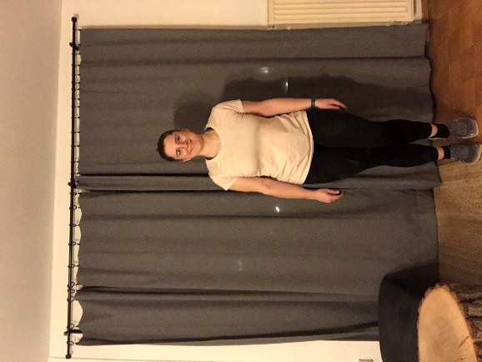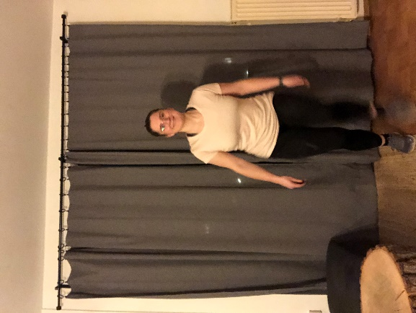 (2x Sprung von links nach rechts)

Is hung where you can see

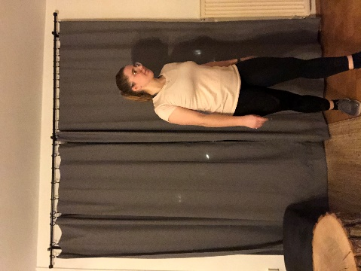 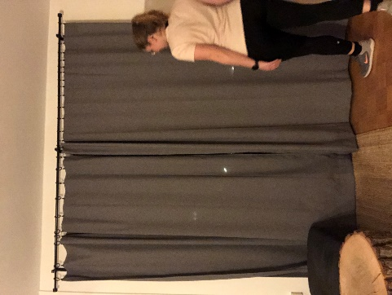 (Kreis in die andere Richtung gehen)  
Somebody waits for you

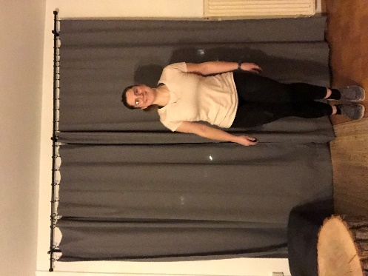 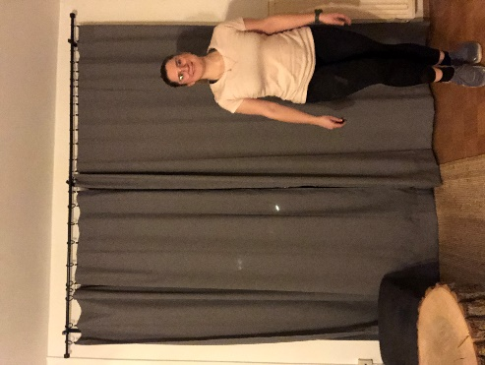 (2x Sprung von rechts nach links)  
Kiss her once for me

**Wiederholung der ersten Tanzschritte des Refrains**

Have a holly jolly Christmas  
And in case you didn't hear  
Oh by golly have a holly jolly Christmas  
This year

**Wiederholung der Tanzschritte**

Ho ho the mistletoe  
Is hung where you can see  
Somebody waits for you  
Kiss her once for me

**Wiederholung der Tanzschritte des Refrains**

Have a holly jolly Christmas  
And in case you didn't hear  
Oh by golly have a holly jolly Christmas  
This year